2.1 BUILDING NETWORK TECHNICAL ANALYSIS
by Elvis Avduli, E22001
Description:
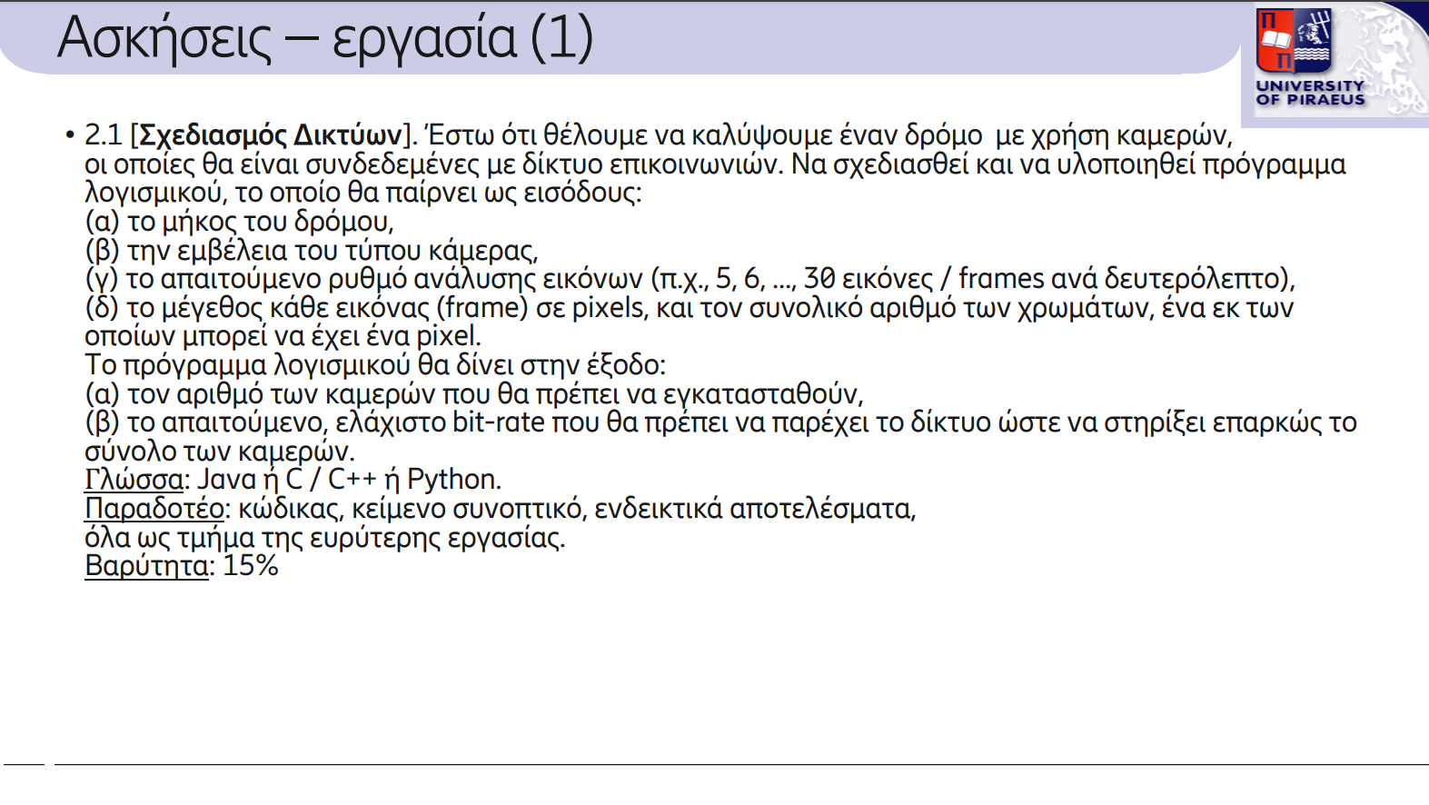

Solution:
The program aims to cover an area with cameras connected to a communications network. The program needs the length of the road we want to put on cameras, the range of the camera, the frames per second the camera analyzes the image, and the size of the image in pixels (we assume the image is square). The output consists of the number of cameras we need to cover the road and the minimum bitrate so the network can support all the systems.

Inputs:
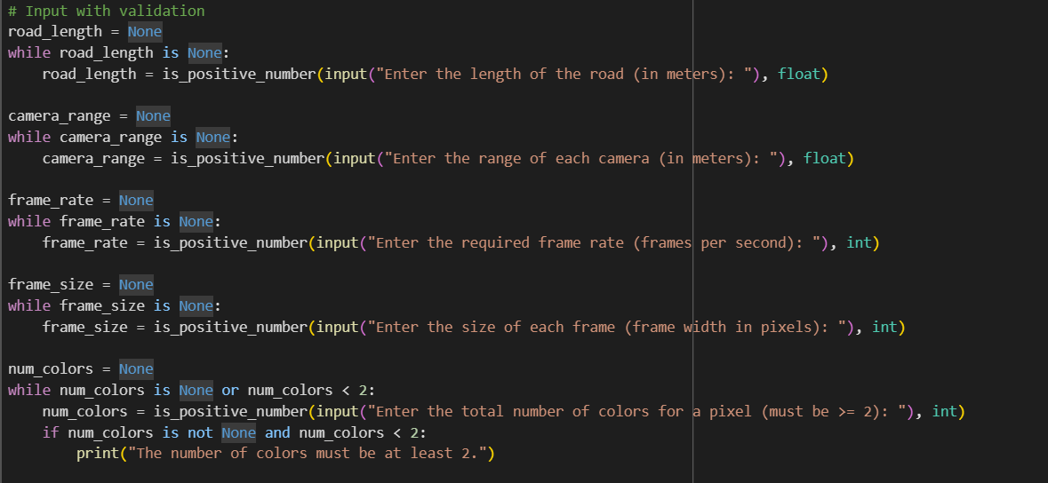
In our program, all inputs must be non-negative float or integer numbers. After entering each value, a method should be called to validate it. The length of the road is measured in meters, and each camera's range is a float number. The number of pixels required, frames per second (fps), and the number of colors each camera can display are integers. The validation method accepts two parameters: the value and the expected data type for that value. If the actual data type of the value does not match the expected type, an error is raised. Additionally, if any of the values are not positive numbers, an error message is displayed.

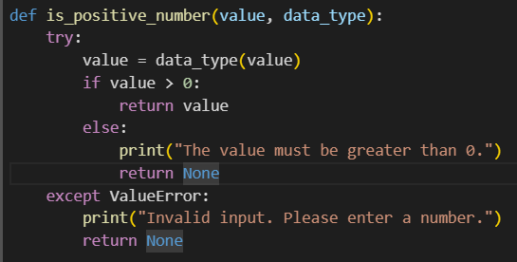

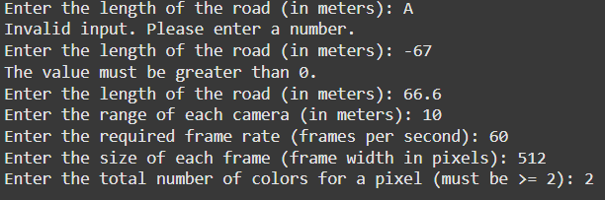

Calculations:
The program calculates the number of cameras needed by dividing the road length by each camera’s range. If this division results in a decimal, an additional camera is added to ensure full coverage of the road.
The program also determines the minimum bit rate required for the network to support the entire camera system. First, it calculates the number of bits per image, based on the number of colors each camera can display. This bit depth is influenced by the number of colors available, and determines the bits required for each pixel. Next, the bits per pixel are multiplied by the size of each frame (assuming the frames are rectangular) to determine the total bits per frame. Finally, this value is multiplied by the frame rate (fps) to calculate the bit rate needed to support all camera data effectively. This approach ensures that the network can handle the data output from the entire camera system smoothly.

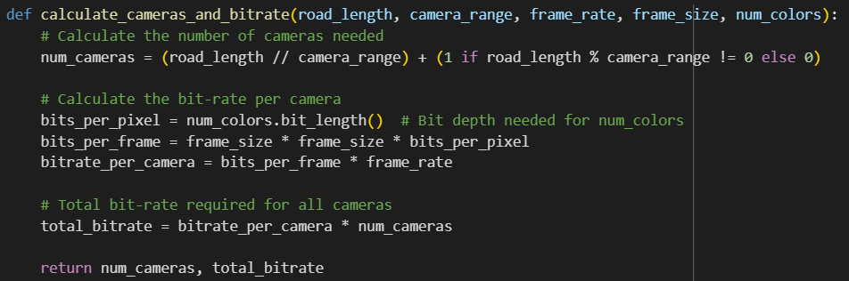

Output:
